

ISY5001 INTELLIGENT REASONING SYSTEMS

Group Project Report

**Adaptive System**

NACHIKETH DORAISWAMY (A0215523N)

LAKSHMI SUBRAMANIAN (A0215255L)

YALAVARTI DHARMA TEJA (A0215457A)

Table of Contents

Contents

1.0 EXECUTIVE SUMMARY………………………………………………………………………………………………………3

2.0 PROBLEM DESCRIPTION……………………………………………………………………………………………………4

2.1 PROJECT OBJECTIVE……………………………………………………………………………………………………4

3.0 PROJECT PLANNING…………………………………………………………………………………………………………..5

4.0 KNOWLEDGE MODELLING………………………………………………………………………………………………....6

4.1 KNOWLEDGE ACQUISITION………………………………………………………………………………………….6

4.2 KNOWLEGDE REPRESENTATION………………………………………………………………………………….7

5.0 SYSTEM IMPLEMENTATION……………………………………………………………………………………………….8

5.1 SYSTEM ARCHITECTURE………………………………………………………………………………………………8

5.2 PROJECT SCOPE…………………………………………………………………………………………………………...11

5.3 ASSUMPTIONS……………………………………………………………………………………………………………..11

5.4 SYSTEM FEATURES………………………………………………………………………………………………………12

5.5 LIMITATIONS……………………………………………………………………………………………………………….13

6.0 CONCLUSION………………………………………………………………………………………………………………………14

7.0 BIBLIOGRAPHY…………………………………………………………………………………………………………………..15

# 1.0 EXECUTIVE SUMMARY

**“Education is the only way to win the world. It is to think deeply about something till its roots and understand the intention behind it”. - Unknown**

Education is the social institution through which society provides its members with important knowledge, including basic facts, job skills, and cultural norms values.

This year alone we have witnessed an investment of about $5.6 trillion on education and training globally by governments, educational institutes, families, etc. and it is expected to grow by 4.5% between the years 2021-2026. Undeniably, education plays a crucial role in reducing poverty and inequality and laying a foundation for sustained economic growth. Governments are expected to develop and implement strategies that promote education and enrolment of students. High-enrolment in education can translate into more skilled labour, which can provide a positive impact on a country’s GDP.

One of the most important benefits of an education at an individual level is that it improves lives and helps society to run smoothly. Therefore, assessments are a way to test the skills acquired.

Assessment evaluates the student’s ability of learning. It is an analysis of the student’s understanding, a measurement of how much they learn. The primary goal of assessments is for self-improvement.

The level of modern assessment evaluation can be further enhanced by unlocking the potential of **adaptive assessments**.

# 2.0 PROBLEM DESCRIPTION

Even though adaptive assessments are the need of the hour, we still see most of the education system practicing conventional testing systems. The current system emphasizes evaluation based on fixed-form tests where each student gets an unvarying set of questions to answer. The problem with this approach is, a student with an ability level at one extreme or another will not be measured in an efficient or useful way by this method of assessment which is designed to better evaluate the average student. Moreover, higher-ability students will have to trudge through many easy questions that provide no information on their ability, while lower-ability students may become frustrated with questions far beyond their range of competency. With the latter group, there is also the possibility of guessing which can make the analysis and interpretation of data messier.

**If we believe that education should meet each student's academic needs, why wouldn't we use assessments that adjust to their achievement levels?**

An adaptive test can typically maintain a higher level of precision than a fixed version by adapting to the student’s ability and setting up the assessment based on the previous performance of the student. This translates into enhancing the students’ performance progressively based on their abilities. Test-takers need not waste their time attempting questions that are too hard or trivially easy.

# 2.1 PROJECT OBJECTIVE

Our objective is to assist the students by implementing adaptive tests along with providing them an option to search for possible concept explanations using a keyword-based solution system.

# 3.0 PROJECT PLANNING

In this phase of the project the team was broadly involved in gathering and performing requirement analysis.

The key tasks involved were:

1. Performing task wise requirement gathering as well as breaking down each task into its corresponding subtasks.
2. Assigning each task to individual team member.
3. Deciding the timeline for each task.

|  |  |  |
| --- | --- | --- |
| **Timeline** | **Deliverables** | **Owner** |
|  | Get compatible API's for knowledge acquisition |  |
|  | Implement Web Crawlers and build database |  |
|  | Input / Output parameters listing |  |
|  | Business Rules |  |
|  | Genetic Algorithm |  |
|  | Search Based Results |  |
|  | Front-end design & Development |  |
|  | Database Connection |  |
|  | Cloud Deployment |  |
|  | Project management & documentation | All |
|  | Video report | All |
|  | Final Submission | All |

Table 1: Requirement Analysis

As we finished the project planning phase, we commenced with the project implementation phase.

While building our knowledge base we gathered our data by scraping different questions, study material, etc. from different educational websites. We used various Python-based libraries like BeautifulSoup and RAKE. This information was utilized to build our database and maintain it with the help of Mongo DB. The information was then used by the rule-based system created in python.

# 4.0 KNOWLEGDE MODELLING

Knowledge modelling can be classified into two categories:

* Knowledge acquisition
* Knowledge representation

# 4.1 KNOWLEGDE ACQUISITION

# Some of the techniques for knowledge acquisition are as follows:

# Domain Expert (Teachers)

# Online educational website bloggers

# Online student survey

# Case studies

| **S. No** | **Information Source** | **Acquisition Technique** | **Information** |
| --- | --- | --- | --- |
| 1 | Teacher insights and reviews | - Elicitation of tacit knowledge through interviews and mails | - Provided insights on how to set question papers and list of relevant topics to research upon  - Suggestions on relevant study material as well as online educational websites |
| 2 | Educational bloggers | - Elicitation of tacit knowledge through interviews and mails | - Provided with useful information on design and development of various aspects related to type and format of the adaptive question papers |
| 3 | Student Survey | - Online survey from relevant students | - Reaffirm the requirements of the provided suggestions by the teachers |
| 4 | Case Studies | - In-depth analysis of different case studies that are already provided | - Design, architecture and setting up of business processes as well as rules for operation |

Table 2: Knowledge Acquisition Sources and Information

# Interviews and survey results are attached along with this report in Appendix A and B.

# KNOWLEGDE REPRESENTATION

The structure and the acquired knowledge can be further understood with the help of an inference diagram. This diagram highlights the goals of the system and identifies the main goals along with its sub-goals.

# Fig. Knowledge representation of ruleset

# 5.0 SYSTEM IMPLEMENTATION

The system has been developed with the help of MVT design. We have followed the microservice architecture while designing the APIs and the backend server. The system has been designed based on the aspects of it being user-friendly and easy to navigate.

# 5.1 SYSTEM ARCHITECTURE

# 

The entire system backend is based on Django rest framework which makes it easier to breakdown the entire application into smaller services but at the same time makes it easier to integrate them as loosely coupled services. We have provided an easy to use front end framework which would interact with the backend. It is a modern server-side Python template engine for both web as well as standalone environments. The server-side collects all the information from the front-end and fires the query dynamically based on the request provided via the front-end and also guided by the business ruleset defined in the application. The Mongo DB stores and persists the data and provides it as and when necessary. The backend collects all the necessary information and displays it in the front-end.

**Data scrapping method:**

We have used python libraries such as BeautifulSoup and RAKE to retrieve questions and study material for relevant topics from different educational websites. The data was then consolidated and stored in the database with an autogenerated ID behaving as the primary key for the tables. Using these libraries, we built a question bank. The structure of all the tables used is attached for reference with the name data.csv at the bottom. RAKE is used to extract keywords from the solutions to assist the students to review the previous test solution.

**Components of backend system:**

The backend services can be mainly divided into three categories:

* **Genetic algorithm** for setting of the question paper for students in an adaptive manner by providing an optimum set of questions based on an individual’s performance
* **Rulesets** to decide the difficulty of questions being assigned to students based on previous performance.
* **Search** based on cognitive statistical search system which enables students to search for relevant information.

**Genetic Algorithm:**

The questions for the new test will be generated based on the student’s previous test scores. The objective of the algorithm will be to train the students more on topics that they have scored less and improve accordingly by giving questions of appropriate difficulty level (will be decided by the ruleset). For example, if there are 3 topics say Topic A, Topic B, and Topic C, and the previous total scores for these topics are 100%, 20%, and 60% respectively. The input to the GA module will be the complement percentage (i.e. 0%,80%,40%) of scores. The number of questions per topic will be generated by the GA such that it tries to minimize the difference between the ratios of the previous test scores and the ratio of newly initialized number of questions per topic, i.e. if the GA randomly initializes the chromosome viz ratio of questions to say (4,5,1) for the topics respectively, the objective will be to minimize the sum of absolute difference between (0,0.6667,0.3333) and the ratio of questions per topic (0.4,0.5,0.1). The constraints will be that at least one question will be covered per topic, therefore the number of questions per topic will be in the range [1, total number of questions].

**Rulesets:**

The difficulty level of the questions will be decided by the rulesets defined. Percentage of marks obtained in previous test in every topic and every difficulty level (easy, medium and difficult) is analyzed, if the percent of marks obtained in a particular topic of a particular difficulty level is less than 50% then we mark it as 0 else it is 1. Based on the survey conducted from the teachers, we have taken the max response and prepared a ruleset for each possible combination of easy, medium and hard. For example, the difficulty score for a student obtaining marks (0.4, 0.8, 0.4) for easy, medium and hard respectively, for which the student is expected to improve more from the basics and the easy ruleset is activated to generate 75% of the questions assigned to the topic with difficulty level as easy and remaining 25% of the questions will be given from the medium difficulty level. This way we can calculate the difficulty level scores for each topic and the questions are generated accordingly.

**Search:**

Students can find solutions by just searching for relevant information. As soon as the student requests for something an API request is fired which runs a TF-IDF algorithm at the backend. TF-IDF is a statistical machine learning algorithm which finds the closest sentence for a particular input based on statistical probability formula.

# 5.2 PROJECT SCOPE

The scope of our project is to implement adaptive assessment based on student’s previous performance and also provide him/her with a feature to search for information on subject related queries thereby empowering and encouraging the student to perform well gradually in the subsequent assessment. Hence the result that we are achieving here is improving the student ability and capability by conducting adaptive assessments that challenge the student at both extremes of their ability.

Our system will set the assessment based on the student’s previous assessment’s performance. Once the student submits the answers to the current assessment, the teacher then evaluates the assessment and uploads the score. The student based on the score and other information on the portal would know what are the mistakes they have made or where they are lacking in the subject and then has an opportunity to study more on the same using the search tool provided and then try to attend the next assessment, which would now have more questions from the topics that the student was lacking earlier, and score well. This approach not only helps the student improve in the topics that they are lacking but also enhances their confidence level as we are encouraging them by the necessary tools to not give up on their weak areas in the subject.

The data is mined according to the structure of the database design as well as various inputs from the student survey and domain expert knowledge. Our project will cover certain concepts of Machine Reasoning like setting up business rule sets which would govern the processing of data, Reasoning Systems like the Genetic Algorithm, and Cognitive Systems for a solution-based system that will find relevant solutions to the questions.

# 5.3 ASSUMPTIONS

Assumptions that were made while building the system are:

* The main target audience are the students that want to evaluate their knowledge and understanding of various concepts with the help of these mock assessments.
* The entire system has been designed based on the inputs of a few teachers and students. Therefore, it is possible that the system may not represent everyone but only a sample of the population.
* Only a limited set of subjects and topics have been taken into account as requested by the sample population and hence, may not include the views of the entire population.

5.4 SYSTEM FEATURES

5.4.1 System Reusability & Scalability:

Firstly, our frontend and backend are decoupled by REST Application Programming Interface (API). This means that our frontend can be used with any other backend easily and vice versa. For example, if we deploy several different rules engine on many backend servers, frontend just need to change the API to get result from different engines. On the other hand, our backend can be used by many other frontends too as long as the API contract is satisfied.

Additionally, our questionnaire form can be easily modified and expanded as necessary. This is because the questions are not hardcoded into the HTML, but instead they are loaded from JSON file. Hence any modification to the questions in the future can be done by only change in the JSON file.

5.4.2 Ease of Usage:

Once the system is deployed, it has an interactive front-end user interface, it can be easily accessed and used by any individual (student or teacher).

5.4.3 Backend Rules:

Our backend service which is based on genetic algorithm and rules engine is the backbone of our system. With these, our system can easily analyze all the data received and arrive at the conclusion to set the best possible assessment for the student. This is the primary feature of our system.

5.5 LIMITATIONS

In our current implementation we are using the adaptive assessments to enhance student’s understanding and ability only through mock tests and until the final/semester assessment.

In the final semester assessment, it would be unfair to the students if the assessments generated are not of same weightage/difficulty level.

However, going forward, we can tune our system to cover the final/semester exam too where the algorithm would be able to set assessment which still has different set of questions for different students but with the same weightage/difficulty level of the assessment as a whole for all the students.

# 

# 6.0 CONCLUSION

The group discussion session was fruitful and rewarding as we have learnt much from each other. Even though every one of us has personal commitment on our work, we still committed a substantial portion of our rest time and weekend to deliver the project. The time spent on this group project was not wasted, the joy of witnessing the completion of final product was unforgettable and we are glad that we have successfully achieved our objective of setting adaptive assessments to the students.

FUTURE IMPROVEMENTS:

1. Can be improved to implement this concept to multiple other subjects or exams that contain formulas and pictures in their questions and answers.
2. Can be improved to implement this concept in final/semester assessments.
3. Can be improved by adding a feature that can do auto-evaluation of the answers submitted by student thereby providing the teacher with more time to work on quality lecturing and other related work.

# 7.0 BIBLIOGRAPHY

Question set data scrapped from https://www.learncbse.in/chapter-wise-important-questions-class-10-science/

Physics question set retrieved from <https://byjus.com/jee/hc-verma-solutions-class-11-physics/>

Data for the chapter **chemical reactions and effects** scrapped for chemistry from <https://intl.siyavula.com/read/science/grade-8/chemical-reactions/07-chemical-reactions>

Data for the chapter **human evolution** for Biology from https://www.nature.com/articles/s41467-017-02724-5

Stop words list for RAKE retrieved from <https://gist.github.com/larsyencken/1440509>

Data for the chapter **optics** retrieved from https://www.scientificamerican.com/article/experts-eyes-adjust-to-darkness/

# Appendix

## **APPENDIX A: SURVEY**

We have attached images of two random surveys of two teachers. These sample surveys were conducted on teachers of varying ages and backgrounds. We asked various questions related to the kind and level of assessments required to evaluate the students and these are the responses we received:

TEACHER SURVEY 1: SCENARIO 1

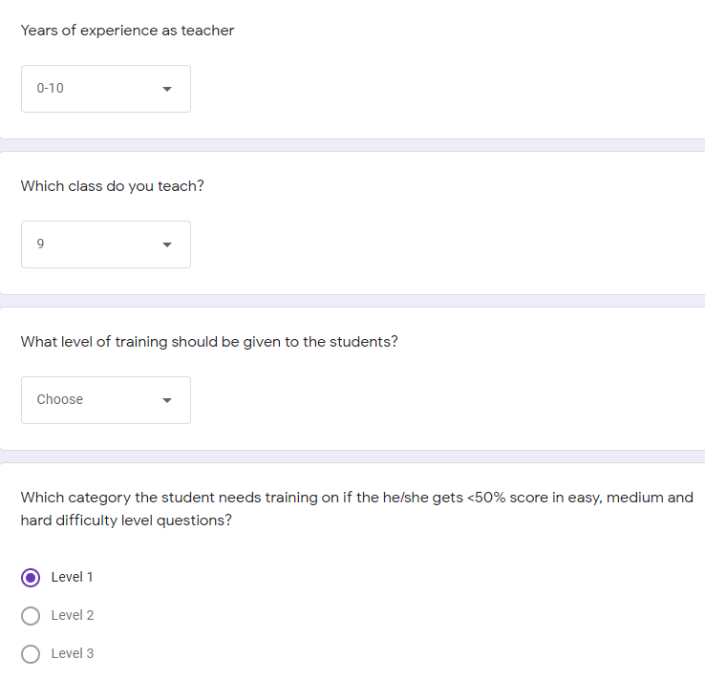

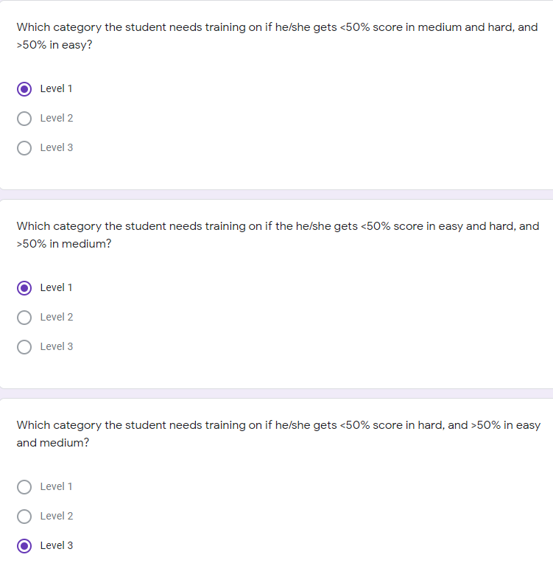

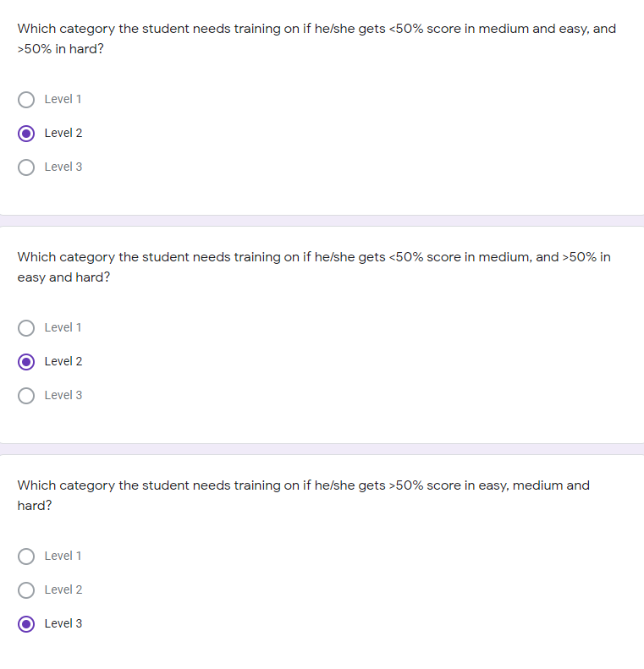

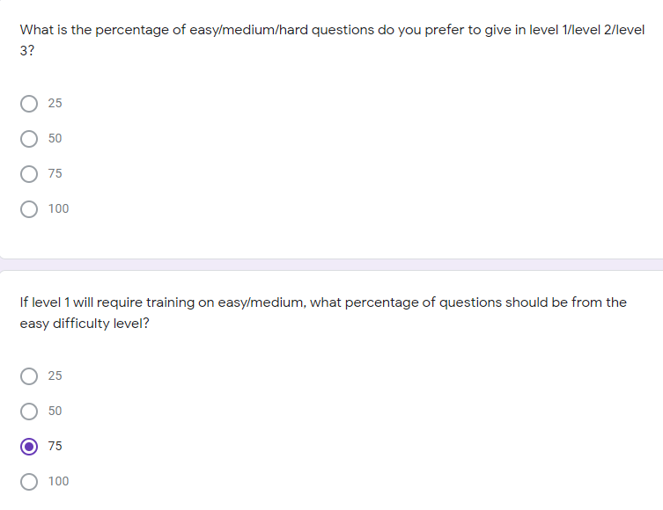

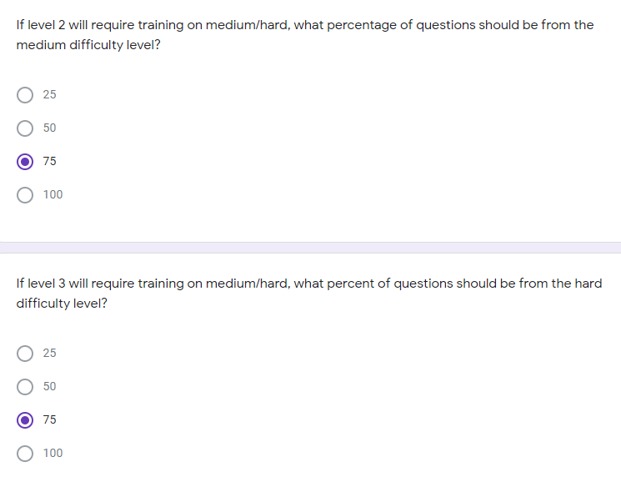

TEACHER SURVEY 2: SCENARIO 2

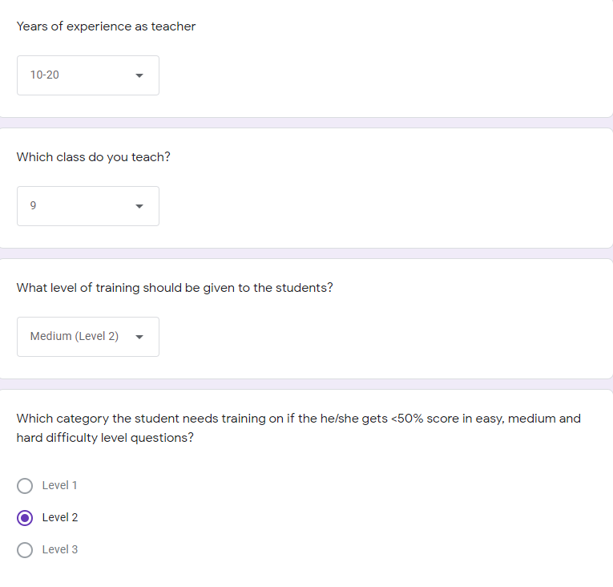

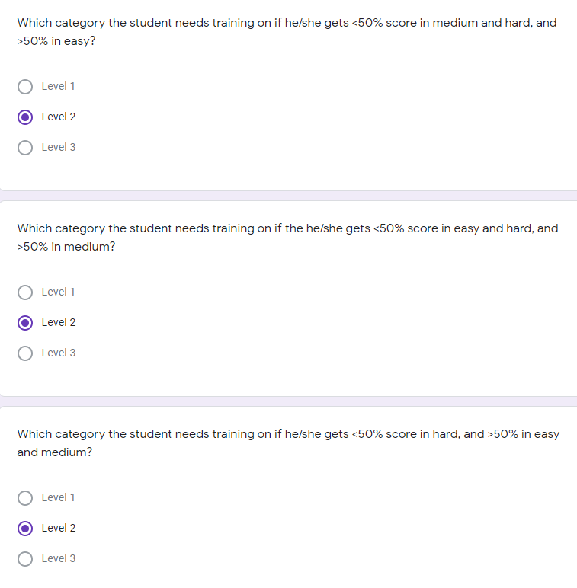

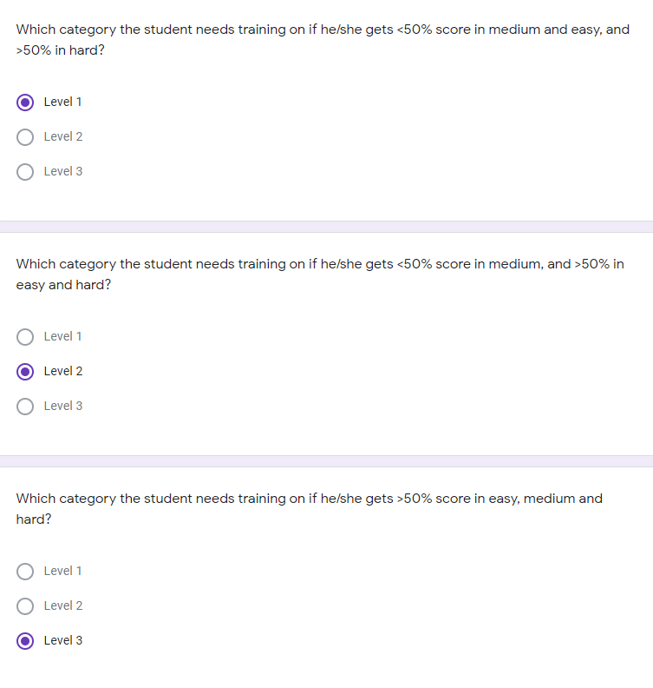

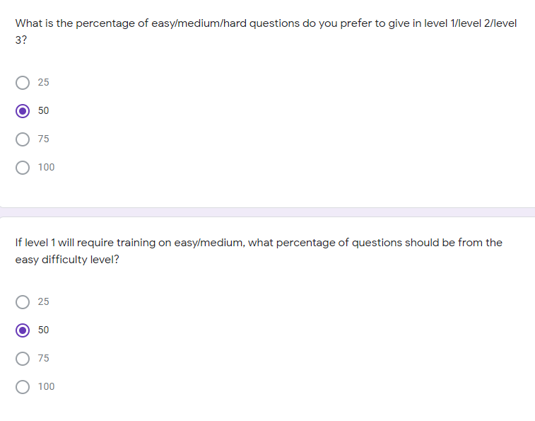

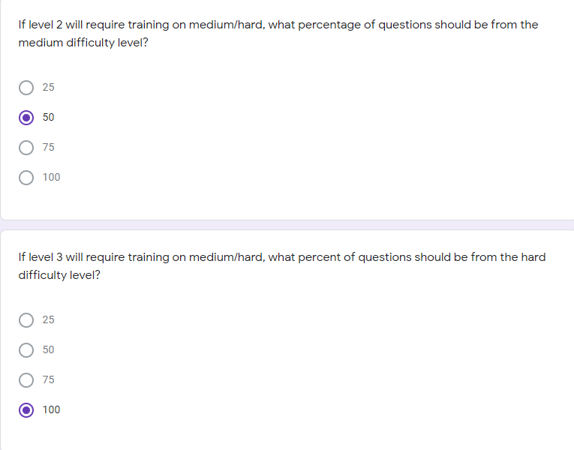

## **APPENDIX B: SURVEY RESULTS**

The survey was conducted for fifteen teachers and the results are as follows:

